SOP: How to use the Farobolrpt.rpt in Accellos Special fields for displaying in Bill of Lading.
  - There are some fields in Accellos that populate on the FaroBolrpt.rpt First set the bol report for the client to Farobolrpt.rpt in the Crystal Reports setup with the client filter set.
  - Note: This is an IT function to set the proper report. The following information is for the Operations Department.

- The first undocumented field is Ship_udf2 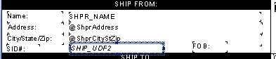 which we find in the ship from screen. This is used in the shipping screen so make sure ready to upload is unchecked. 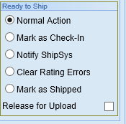 Enter enter the value in the following place. Where we find the Appt /conf# in the screen for shipping. 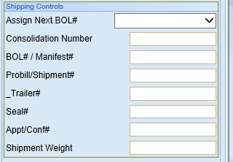
- We next find the trailer number and the Seal which is entered in the screen above while shipping and the release for upload is still unchecked Using the appropriate fields in the shipping screen above we can populate the BOL Fields seen here.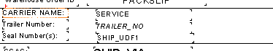
- We have Instructions 1-6 in the header and they are tagged as allow to grow if necessary. This allows the Operations Department to display special notes on the BOL.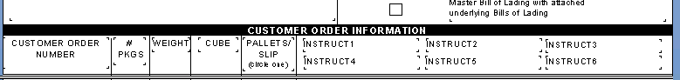 and these can be entered on the Edit tab General 4 in the third Column 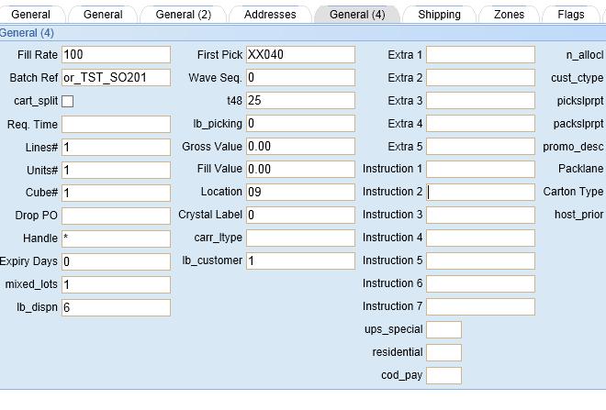
- Using the Instruction 7 field seen above we can then on the bottom of the BOL fill in an appointment time or special Instruction for the driver by the Load and counted fields 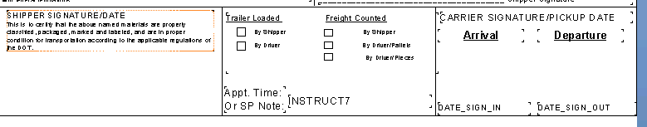
- To get the proper Header for the client’s BOL, the client setup needs properly set in the configuration by IT in the field Company/Client Name 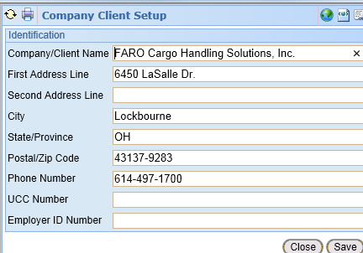

This should help in putting information on the generic Faro BOL.

