SOP: JILL-E STAPLES 
Note: Routing Guide Link : Staples Routing Guide 2013

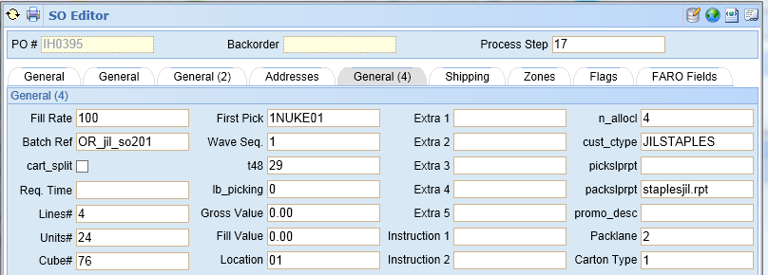
  - It is important that we properly setup the products so let’s begin there
- All products being shipped must have product master fields prod_udf1 and prod_udf2 on the additional TAB set to the proper values. These must be acquired from Jill-E to proceed.
  - Prod_udf1 = Staples sku
  - Prod_udf2 = scc-14
  - 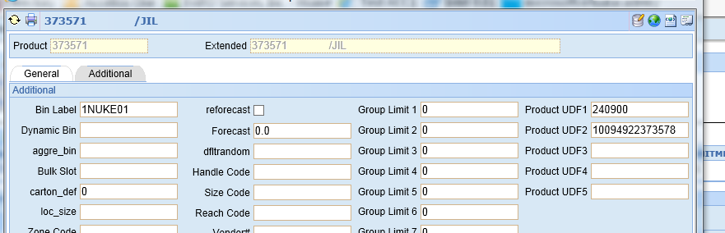

The next important part is the proper N of M label settings and the Proper Pack Slip

- On the actual order we must check the Cust_cType and the Pack slip report fields on the General(4) Tab.
  - Cust_ctype = JILSTAPLES
  - Pack Slip Report set to staplesjil.rpt

We now have two scenarios Mixed Pallets and Single SKU Pallets. We will first cover Single Sku per pallet.

  - We allocate the order from the proper Zone and then go to wave. We set the label type to pallet knowing we have just 1 pallet for this order we click on Start with N label and enter 1 into Number of labels.
  - Note: If we have 7 pallets we would enter 7 into Number of Lables.
  - Click the Submit Button.
    - . 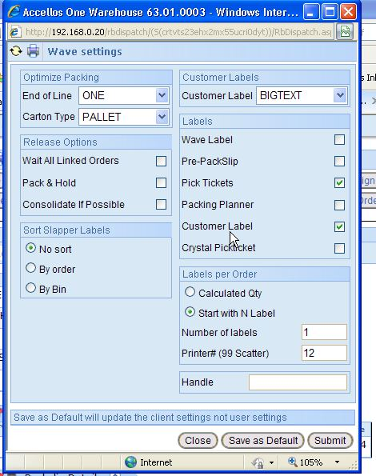
  - Next we can log into the Hand Held to add the items to the pallet tote labels. We will use the Web based for this SOP. It’s highly recommended that you use the hand helds to validate the proper items are added to the proper pallets.
  - Stick a label on the pallet and now add your items. Remember that the maximum height on any pallet is 52 inches by Staples requirements. See the Staples routing guide attached to the help desk for further information on proper label and shipping requirements.
    - Log into http://192.168.0.20:81 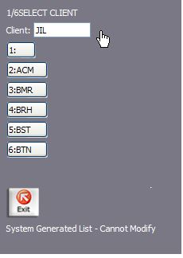 pick JIL as your client.
    - Begin by using the picking option 4. 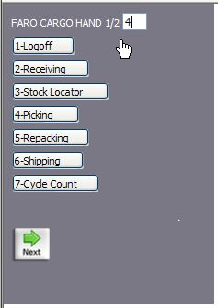
    - Use Regular Picking option 1. 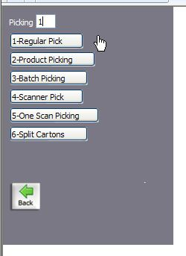
    - You can set your zone or leave blank. 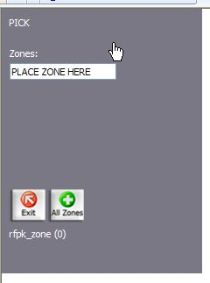
    - Now you can set starting and ending bins if you care to this is optional. Ending bin shown below left blank hit enter or click skip. 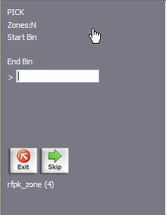
    - Now we enter our Pack Slip number to begin the actual picking process. 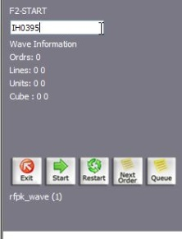
    - We confirm this is the one we want. 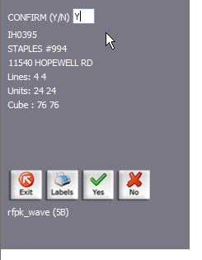
    - We click the start button or on the hand held click F2 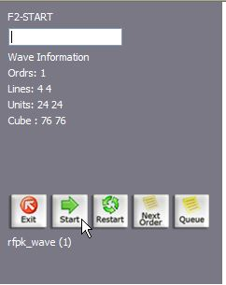
    - We enter the product for first pick. 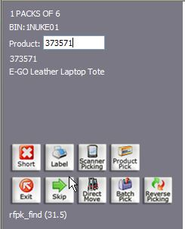
    - We scan our label or enter the tote Number 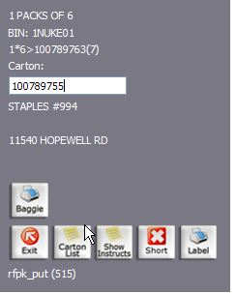
    - And we finally enter our value of how many we need. 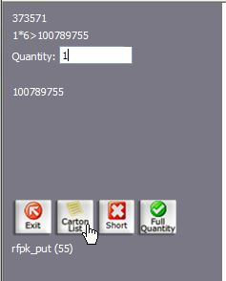
    - We repeat as many times from step ix-xi and then end our picking progress. 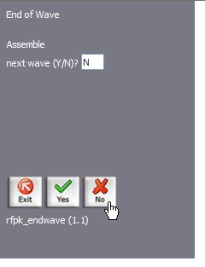
- Now we have to look at the shipping process. This requires the following information setup prior to shipping We have a tare class and NMFC setting we can setup in the product master on the additional tab. I was informed the values are as such
  - NMFC = 150
  - Tar Class = 18764
  - 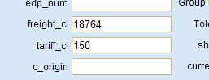
- We setup the ship Carrier prior to BOL generation.
  - Right click on the order in Web Dispatch and click ship option
  - Make sure Release for Upload is unchecked. 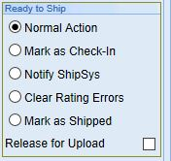
  - Set your carrier which is needed for labels and the BOL. 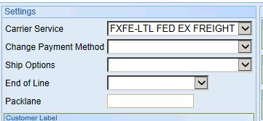
  - Assign your probill/Shipment number if known. This will be reflected on labels if filled in. 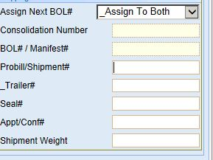
  - Click on submit. 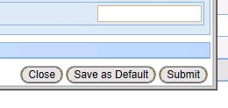
We now can generate our BOL. We are required to use a VICS BOL number so if the is a short Bol Number Don’t use it exit the screen and edit the pack slip on the shipping screen. If Rachel filled in the BOL NUMBER then cut and paste it to the extra1 field on additional fields tab.
- Open the BOL Screen on the top right corner of the pack slip and enter the proper information on cartons / pallets. Set your weight, your Tare class and your NMFC. ( setting are above. Submit and then print after setting your pack slip printer We used 2 here in this example Note that the BOL number in the top left is about 14 characters. IF yours is not then call IT if you don’t understand how to clear this value in the Edit on the pack slip on the shipping tab.
- All Jill- E orders are prepaid unless otherwise stated. Make sure you enter a valid shilp date on the bottom of the screen. The BOL gets affixed to the pallet facing out back of the trailer when loaded. See the routing guide on the help desk attached to the white paper where you got this SOP.
- 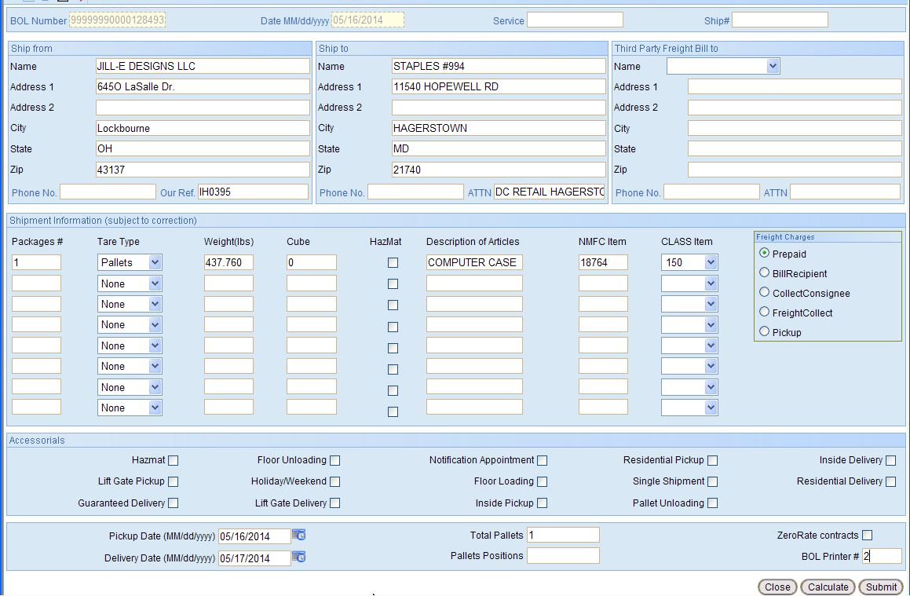
- NNow you can go to label printing since we have properly setup all the values needed.
- Labels are simple for single sku single pallet but remember even mixed pallets need this label printed to.
- Open up printing of labels and pick N of M Enter your tote label or scan one of the labels you put on the pallet itself earlier in step 1e generated at WAVE.
- 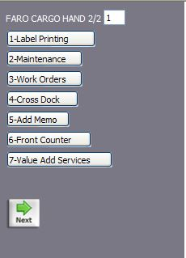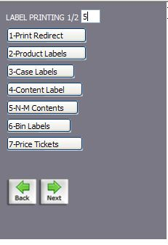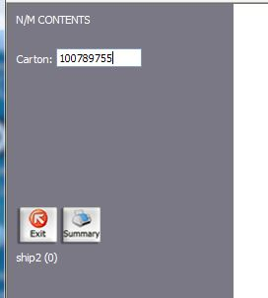
- These should print out 2 labels per pallet. Affix the proper labels on the proper pallets. Make sure the product in the Mfg. Model field matches the product on the pallet if a single sku is used as per the routing Guide. 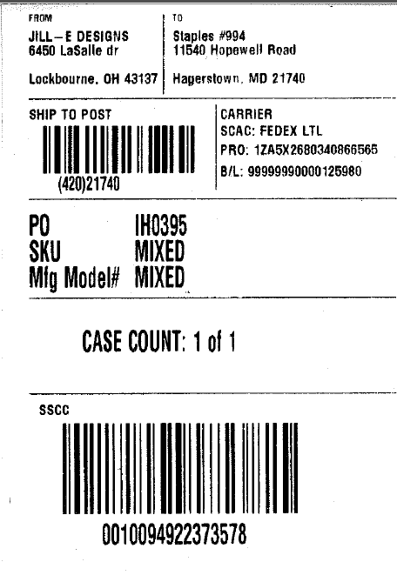
- If you have a mixed pallet. We must go into Label Matrix. Staples requires that mixed pallet cartons must be individually printed.
- This may be confusing but it must be adhered to.
  - If you only have one carton per item on the pallet then it’s a simple as printing from page x to page y
  - But if there are multiple cartons of the same sku on the pallet you must print the same row multiple times and allow the carton counter to increase.
  - The counter must be reset each time you change sku
  - Open the label matrix program and go the folder
    - J:\Labels\Groveport
  - Open the label
    - JILL-E-MIXED CARTON.qdf
  - Your order must be in rating to find it.
  - Click on the database icon. 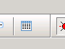 in the header
  - Highlight the Po and the 1st item on the mixed pallet
  - Edit the carton count counter to a value of 1 which is the first numeric value after SKU CARTON COUNT here it is set to 1 ( next page)
    - 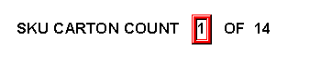
      - Double click and set the value to 1 if it isn’t already
    - Next set the OF cartons to the QUANTY OF THIS SKU IN THE WHOLE ORDER. This is not the total cartons of the order but the total cartons of the sku. In this case we would edit the 14 to our new number.
      - Double click on the OF 14 and change to this new value
      - 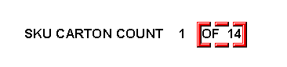
      - Set your printer
      - Now print this same label only the amount of times this sku is on the pallet. Make sure Selected is the proper choice. 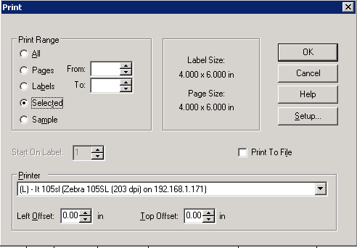
      - After printing the number of labels for this sku, pick the next item.
      - Reset your counters properly
        - Reset the initial counter to 1
        - Reset the OF M string to how many cartons of this sku there are in the whole order
        - Reprint this selected label for each box of this sku on this pallet.

Special Note: if this sku is on multiple mixed pallets then make sure you set your counter to the next number not used for this item
        - So if two mixed pallets have this item
          - First pallet sku item counter starts at 1 through X
          - Second pallet counter starts at X+1 for this item only
This page left blank intentionally

