SOP: Setting Canon Printer to Print from GDS Billing for Proper Page Display
  - Printing from the Canon Printer requires the proper Pitch settings be set to allow the printout to properly set the width of the output
- Log into the printer via the web interface and click on the Add. Func. Menu option
- Pick the Custom Settings menu tab 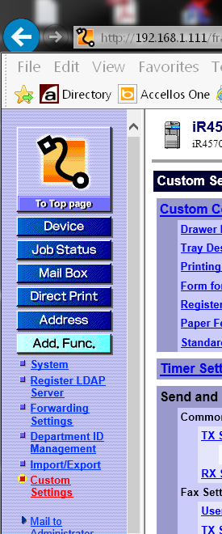
- Click on the PCL settings on the top right side of the web page 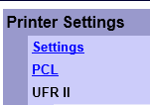
- The Pitch setting will adjust the output proportionally 17 appears to be the proper size 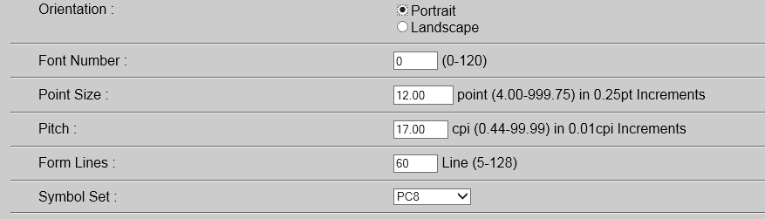
- Click the OK Button to save your changes 

